ST 207 - Assignment 1: E-Commerce Database
Candidate Number: 85009
Question 1 - Conceptual/E-R Modeling:
The database supports the core operations of an online shop: Customer accounts with several addresses, A category tree, Products sold as variants with their own price and stock, Persistent carts, Orders with coupons, Payments (including failed attempts and refunds), Multi-parcel shipment, and Product reviews.

It includes 11 entities: CUSTOMER, ADDRESS, CATEGORY, PRODUCT, VARIANT, CART, COUPON, ORDERS, PAYMENT, SHIPMENT, and REVIEW. Three many-to-many relationships (holds, contains, packs) carry their own attributes. In terms of specialization, none is used; for example, splitting CUSTOMER into guest and registered guests would just add complexity that a minimal system does not need. Account_status and Status attributes record the states instead. Every ADDRESS, ORDERS, VARIANT, PAYMENT, SHIPMENT, and REVIEW must belong to a parent. A customer may have no addresses, cart, orders, or reviews yet. An order may have no coupon, and a top-level category has no parent. Moreover, NULL is used only where a value is absent or not yet known.

Relationships:
# | Relationship | Cardinality & Justification
1 | CUSTOMER has ADDRESS | (1:0…N) A customer can have several addresses (e.g residential, work, shipping office)
2 | CUSTOMER owns CART | (1:0…1) Each customer has exactly 1 basket that extends through sessions
3 | CART holds VARIANT | (M: N, attributes: Quantity, Added_at)  A basket has many variants and a variant can be in many baskets; the quantity belongs to the pair
4 | CUSTOMER places ORDERS | (1:0…N) Order history
5 | ORDERS contains VARIANT | (M: N, attributes: Quantity, Unit_price,) Discount_amount  Records what was bought and the final price paid
6 | ORDER settled_by PAYMENT | (1: 0…N) Failed attempts, successful payments, and refunds are all separate rows
7 | ORDERS fulfilled_by SHIPMENT | (1:0…N) An order can ship in several parcels, each with its unique reference/tracking number
8 | SHIPMENT packs VARIANT | (M: N, attributes: Quantity) Records which items are in which parcel
9 | PRODUCT offered_as VARIANT | (1: 1…N) Price and stock differ by size and colour; a product needs at least one variant
10 | PRODUCT classified_in CATEGORY | (M: N) A product can sit in several categories (e.g tshirts → clothing, tshirts→ tops)
11 | CATEGORY parent_of CATEGORY | (0…1 parent: 0…N children) Builds the browsable category tree; top-level categories have no parents
12 | CUSTOMER writes REVIEW | (1:0…N) Reviews belong to the author
13 | PRODUCT receives REVIEW | (1: 0…N) Ratings are given to products, not individual variants
14 | ORDERS ships_to ADDRESS | (N: 1) Checkout lets the customer choose a delivery address
15 | ORDERS bills_to ADDRESS | (N: 1) A separate billing address; it can be the same row as the shipping address
16 | COUPON applied_to ORDERS | (0..1: 0…N) An order uses at most one coupon; a coupon can be used by many orders

Design Decisions and Assumptions:
- Price and stock live on VARIANT, not PRODUCT: a T-Shirt has no single price or stock level; the medium black one does. This supports separate stocks and prices per variant.
- Order lines copy the price: CONTAINS stores Unit_price at purchase time, so late price changes never alter order history. The cart stores no price because the live price applies until checkout.
- Payments are a separate entity with one row per attempt: this models failed attempts and refunds without overwriting history. Payment_status takes the values pending, failed, succeeded, and refunded.
- Two links from ORDER to ADDRESS: Shipping and billing are different roles, so they are two separate relationships.
- Order totals are not stored: They can be derived from the order lines, discount, shipping, and tax, so storing them would risk inconsistencies. A view computes this in Q5.
- SHIPMENT_ITEM was added: it ensures that the multi-parcel use case is real. Without it, the database could say an order has two parcels, but not what is in each.
- Out of scope for a minimum system: wishlists, product images, stock by warehouse, tax rules, and return processing.

Question 2: Relational Model
The E-R model maps to 15 tables, listed with every attribute, type, and constraint in the data dictionary. The relational diagram is submitted separately.

Adaptations from the E-R model:
- Many-to-many relationships became tables. Product to category became CLASSIFIED_IN (Product_id, Category_id). Cart to variant became HOLDS, which also stores the relationship attributes Quantity and Added_at. Order to variant became CONTAINS, with Quantity, Unit_price, and Discount_amount. Parcel to variant became SHIPMENT_ITEM, with Quantity. Each has a composite primary key made of its foreign keys, which also stops the same variant from appearing twice in one cart, order, or parcel.
- Recursive relationship. The category tree is CATEGORY. Parent_Category_id is a foreign key to the same table, NULL for top-level categories.
- Two relationships between the same entities. ORDERS has two foreign keys to ADDRESS, Shipping_address_id and Billing_address_id, since shipping and billing are different roles that may point to the same row
- Composite and multivaried attributes. There are no multivalued attributes in the model. A customer’s several addresses are rows of ADDRESS rather than repeated columns, and an address is stored as atomic columns (Line1, Line2, City, Postcode, Country). A name is split into First_name and Last_name. Each entity has an auto-increment integer surrogate key. Natural identifiers (Email, Sku_code, coupon Code, Transaction_ref) are UNIQUE alternate keys
Views:
One view, v_order_total was created. It joins ORDERS to CONTAINS on Order_id and groups by order. Its attributes are Order_id, Customer_id, Order_date, and Order_status (from ORDERS), items_subtotal (the sum of CONTAINS.Quantity multiplied by Unit_price), and order_total, which is items_subtotal minus ORDERS.Discount_amount plus Shipping_fee and Tax_amount. Totals are derived, so storing them in ORDERS would risk them disagreeing with the order lines. A view keeps one definition that three queries reuse. An order with no lines does not appear in it.

Cardinality and Participation Constraints:
Rule in the E-R Model | How the Schema Enforces it
Mandatory participation on the “many” side (an address, order, variant, payment, shipment, or review must have one parent) | Foreign key declared NOT NULL: ADDRESS.Customer_id, ORDERS.Customer_id, Shipping_address_id and Billing_address_id, VARIANT.Product_id, PAYMENT.Order_id, SHIPMENT.Order_id, REVIEW.Customer_id and Product_id
Optional participation: an order may have no coupon; a category may have no parent, and some attributes may be unknown | Nullable foreign key: ORDER.Coupon_id, CATEGORY.Parent_Category_id
Maximum of one (one cart per customer, one review per customer per product) | UNIQUE on CART.Customer_id and on REVIEW (Customer_id, Product_id)
A parcel holds only items of its own order | Composite foreign key SHIPMENT_ITEM (Order_id, Sku_id) referencing CONTAINS
SQL cannot declare some minimum cardinalities. A product needs at least one variant, an order at least one line, and a parcel at least one item, but a parent row must exist before its children, so a plain constraint would block the first insert. These rules are left to the application, which inserts parent and children in one transaction. Rules that depend on other tables, namely stock availability and coupon validity, are enforced by triggers.

Other adaptations:
SHIPMENT_ITEM carries Order_id, which ERDPlus does not generate for this relationship. It was added so the composite foreign keys above tie parcel contents to their own order.

Question 3: Database Creation
The database is built by 4 scripts run in this order: 01_schema.sql → drops and recreates all 15 tables, 02_data.sql → inserts the sample data, 03_queries.sql → one view and nine queries in three use cases, 04_triggers.sql → four triggers covering two integrity risks

Order of Creation: Tables are created parents first, so every foreign key points to a table that already exists. The view v_order_total is created after the base tables and data, because it reads ORDER and CONTAINS. The script also begins with “DROP TABLE IF EXISTS” for every table, children before parents, so it can be re-run to give a clean database each time.

No Foreign Key Relaxation was needed: In this database, the only self-reference is CATEGORY.Parent_Category_id, which SQLite accepts inside CREATE TABLE, and the data is loaded parents first. The composite foreign key from SHIPMENT_ITEM to CONTAINS works because CONTAINS has a primary key on exactly Order_id and Sku_id.

Triggers are created after loading: The sample data already contains historical orders, and the stock figures are current. Creating the stock trigger first would subtract the loaded orders from stock a second time and give wrong stock levels. Loading first and creating the triggers afterwards avoids this.

SQLite Specifics: Foreign keys are only enforced when “PRAGMA foreign_keys = ON” is set, and it must be set on every connection, so every script starts with it. SQLite also does not check that a foreign key’s parent table exists when a table is created; it only fails when a row is inserted. Two mistyped references (HOLDS points to a non-existent table SKU, and PAYMENT to Order_status) were therefore not noticed until the data load. They were found by listing every foreign key with its target table using “pragma_foreign_key_list” and then corrected; the same listing is not a check that all targets are real tables.

Question 4: Data Sources and Loading
Sources:
No external dataset was used. All data are synthetic and were coded by hand in 02_data.sql, using fictional names, example.com email addresses, placeholder password hashes, and fictional UK addresses. The data was generated as INSERT statements with explicit key values where other tables refer to them
Table (rows) | How it was generated
CUSTOMER (5), ADDRESS (6) | Typed. Phone and date of birth left NULL for some customers; one customer has two addresses (shipping, billing) and the rest one
CATEGORY (6), PRODUCT (5), CLASSIFIED_IN (9) | Typed with fixed IDs. A two-level tree and four of five products in both a child and a top-level category.
VARIANT (8) | Typed. Prices 10 to 80, stock 5 to 100; headphones and phone cases have no size or colour.
COUPON (3) | Typed: one unlimited, one single-use, one expired
CART (2), HOLDS (3) | Typed for two customers with saved baskets
ORDERS (5), CONTAINS (7) | Typed: orders from September to October 2026, one for each status path; Unit_price copied from the variant's price
PAYMENT (7) | Typed: a failed attempt, success, and refund for one order; only a failed attempt for another
SHIPMENT (4), SHIPMENT_ITEM (5) | Typed: one order split into two parcels, one parcel still in transit
REVIEW (4) | Typed: ratings 2 to 5; one product has no review

Process to keep the data consistent:
- Arithmetic: each payment amount was calculated as the item total, minus the order discount, plus shipping and tax.
- Insert order: Rows were inserted parents first, so every foreign key was satisfied, and foreign key enforcement was on during loading.
- Stock: stock values are the current stock, so the data were loaded before the triggers.
- Checks: after loading, four queries counted rule violations that foreign keys cannot catch: orders whose customer does not exist, orders shipped to another customer’s address, parcel quantities above the quantity ordered, and parcels whose items belong to a different order. All should return 0, and “PRAGMA foreign_key_check” should return nothing.
Limitations:
With five customers and five orders, results such as the basket analysis and customer segments are illustrative rather than statistically meaningful.

Question 5: SQL Use Cases
Use Case 1: Customer Order History
Rationale: Order history is the most common customer-facing operation, and it tests whether the model keeps what was bought and the price paid. Query 1a joins ORDERS, CONTAINS, VARIANT, and PRODUCT for customer 1 and reads the price from CONTAINS.Unit_price, so it stays correct if the variant’s price later changes. Query 1b uses the view and a window function (SUM OVER, partitioned by customer) to show a running total of spending per customer. Query 1c uses a NOT IN subquery to find orders with no successful payment.

Results: Query 1a returns three lines: two T-shirts and a hoodie in order 1 (delivered) and running shoes in order 4 (refunded). Query 1b gives Alice a running spend of 67.49 then 137.48; it is gross spend, because it includes her refunded order 4. Query 1c returns only order 5 (pending), whose only payment attempt failed, which is the list a shop would use to chase unpaid orders.
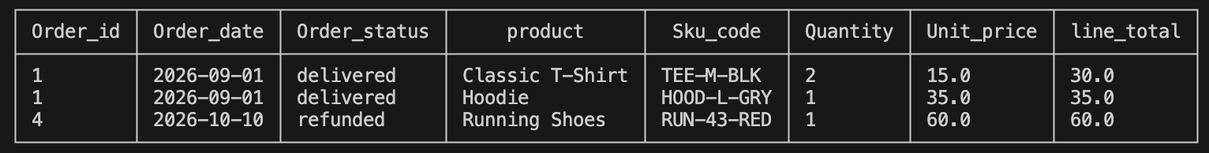
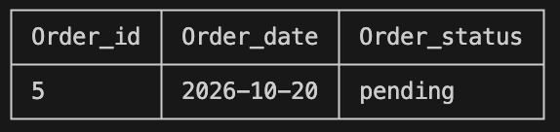
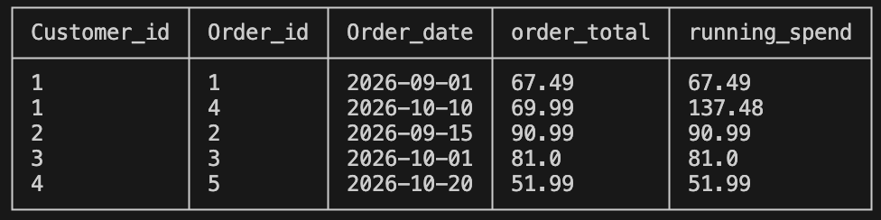

Use Case 2: Browse and Search the Catalogue
Rationale: A shopper needs to navigate categories, find buyable items, and judge quality. Query 2a is a recursive CTE that walks the category tree and builds each category's full path and depth; it works for any number of levels, so new sub-categories need no change to the query. Query 2b searches by keyword and returns only variants that can actually be bought (active product, active variant, stock above zero). Query 2c averages ratings per product with a LEFT JOIN, so products without reviews still appear.

Results: Query 2a returns six categories with paths such as Clothing > Shoes and Electronics > Headphones. Query 2b returns three T-shirt variants (S black, M black, M white), each at 15.00. Query 2c ranks the T-shirt and hoodie at 5.0, running shoes at 4.0, and the headphones at 2.0 (a battery complaint, so a quality issue to raise with the supplier); the phone case has no reviews. Each average rests on one review, so none is reliable yet.
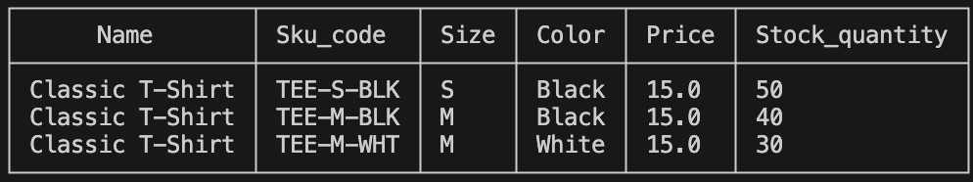
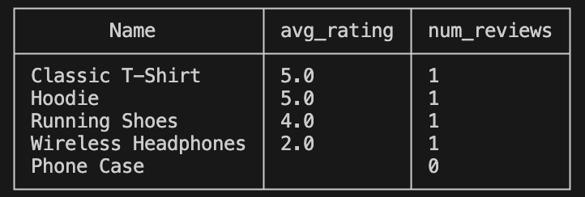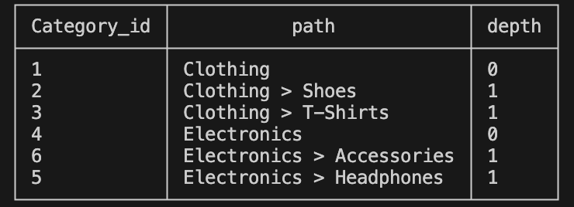

Use Case 3: Marketing Analytics
Rationale: Marketing needs to know what sells together, who the best customers are, and how revenue is moving. Query 3a is a self-join on CONTAINS (with a.Sku_id < b.Sku_id so each pair is counted once) for basket analysis. Query 3b ranks customers by total spend with RANK and assigns a segment with CASE. Query 3c builds monthly revenue in a CTE and uses LAG to calculate the month-over-month change. Segment thresholds (85 and 60) were chosen to suit the small dataset, and refunded and cancelled orders are excluded from 3b and 3c.

Results:
Query 3a returns two pairs, each seen once (TEE-M-BLK with HOOD-L-GRY, and RUN-42-RED with CASE-STD), which is too little data to act on but shows the method. Query 3b ranks Ben first (90.99, VIP), then Chloe (81.00) and Alice (67.49) as Regular, and Dev (51.99) as Low. Query 3c shows September revenue of 158.48 and October of 132.99, a fall of 16.1 percent. One caveat applies to both: Dev's spend and part of October's revenue come from the pending order 5, whose payment failed, so a stricter version would count only orders with a successful payment.
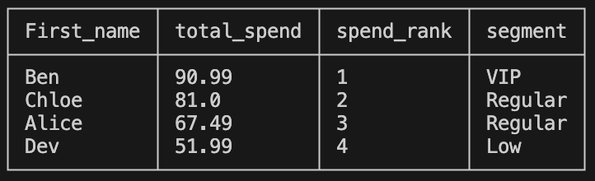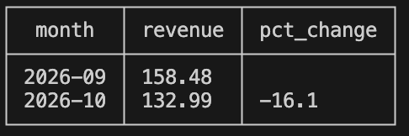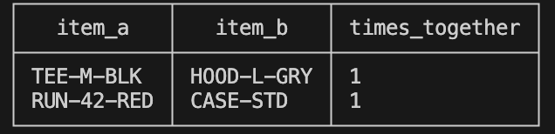

Question 6: Triggers
Two integrity risks were chosen because both are common in real shops and both depend on a second table, so a CHECK constraint cannot express them. SQLite has no stored procedures, so each trigger stops a bad row with “RAISE(ABORT, ‘message’).” Tests were run on a rebuilt database (schema, data, triggers), so stock starts at its original values.
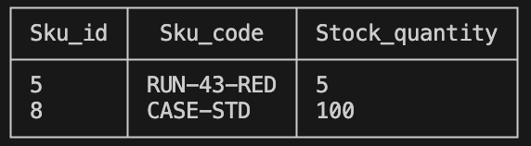

Trigger 1: Stock Availability
Rationale: Without a check, two customers could buy the last unit, or a customer could buy a variant that is switched off, leaving stock negative or wrong. A BEFORE INSERT trigger on CONTAINS rejects an order line if its quantity is above the variant's Stock_quantity or the variant is inactive. An AFTER INSERT trigger on CONTAINS then subtracts the ordered quantity from stock, so stock can only change through valid orders.

Tests:
(i) Passes: Halle orders one phone case (stock 100), and stock becomes 99.
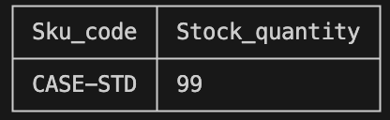
(ii) Fails: 99 pairs of size 43 shoes when only 5 exist, with the error Insufficient stock or inactive product variant.
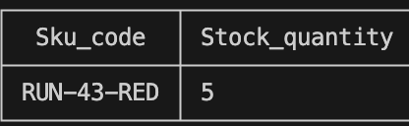
(iii) Edge, passes: ordering exactly the remaining 5 pairs leaves stock at 0.
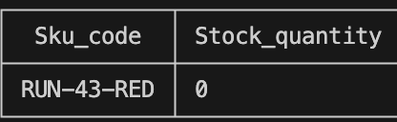
(iv) Edge, fails: ordering one more pair is rejected, and stock stays 0, showing a rejected insert has no side effect. A limitation is that the triggers cover INSERT only, so cancelling an order does not return stock.

Trigger 2: Coupon Validity
Rationale: An expired coupon, or a single-use coupon used twice, would give discounts the business did not intend. Two BEFORE INSERT triggers on ORDERS run only when an order has a coupon. One rejects the order if its date is outside the coupon's Valid_from and Valid_to range. The other counts the coupon's existing non-cancelled orders and rejects the new one if that count has reached Usage_limit; a NULL limit means unlimited. A cancelled order therefore frees the coupon.

Tests:
(i) Passes: a new order with WELCOME10, which is valid and unlimited.
(ii) Fails: an order with the expired coupon OLD20, with the error “Coupon is expired or not yet valid.”
(iii) Fails: an order with SAVE5, which has a limit of 1 already used by order 3, with the error “Coupon usage limit reached”. Limitations: the triggers do not check that the stored discount matches the coupon value, and because ABORT cancels only the failing statement, an order row is kept if a later line is rejected, so an application should insert an order and its lines in one transaction.
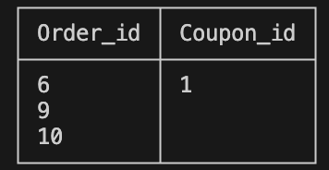

Generative AI Statement:
I used Grammarly to check for typos and grammatical errors when writing my report.

References:
- SQLite documentation, Foreign Key Support: https://www.sqlite.org/foreignkeys.html
- SQLite documentation, AUTOINCREMENT: https://www.sqlite.org/autoinc.html
- ERDPlus, database modelling tool: https://erdplus.com
- ST 207 Course Materials

